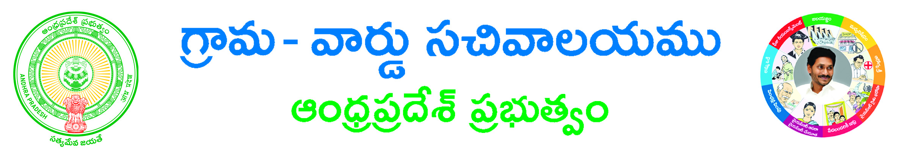

**Fresh or Renewal License Application**

**Applicant Details (address for communication):-**

**Aadhaar Card No: ____________________Name of Applicant (in BLOCK letters)*: __________________­­­­­­­_**

**Surname*: __________________­­­­­­­_Father/Husband Name*: _______________ Gender *: ___________**

**Occupation *: ___________**

**State *: ___________________District*: ________________ Mandal*: __________________**

**Village / Ward *: ______________________ Door No: ________________________________**

**Locality/Land Mark: ______________ Pin Code: ___________ Mobile No*: ______________**

**Email ID: ______________**

**Informant Details:-**

**Informant Name*: _____________________________ Informant Relation*: ___________________**

**Delivery Type*: 🞏 Manual 🞏 Local 🞏 Non-Local Mobile NO*:_____________________**

**Service Specific Details**

**Service required For *(Bars/Dhabas,Fresh 3 star hotel, Fresh 5 star hotel, Renewal 3 star hotel, Renewal 5 star hotel, Ordinary Hotels / Restaurants, Theme / Entertainment Park / Resorts): _____________________________________**

**District/Commissionerate *: _____________** **Police Station Jurisdiction Known *(Yes/NO):_______________**

**If Yes provide Police Station*: _______________, If No provide Nearest Landmark/ Area Description*:_______________**

**Remarks *:_______________**

**Document List:-**

1. **ID Proof**\*
2. **Address Proof**\*
3. **If any other Documents**.

**Applicant’s Signature**